**Top 4 Ways The Latest “ERC-4337” Ethereum Upgrade Will Change NFT**

[ETHEREUM NEWS](https://blockchainmagazine.net/ethereum-news/)

 August 14, 2023 by **DIANA AMBOLIS**

[No Comments](https://blockchainmagazine.net/top-4-ways-the-latest-erc-4337-ethereum-upgrade-will-change-nft/#respond)

[SHARE](https://blockchainmagazine.net/top-4-ways-the-latest-erc-4337-ethereum-upgrade-will-change-nft/) [TWEET](https://blockchainmagazine.net/top-4-ways-the-latest-erc-4337-ethereum-upgrade-will-change-nft/) [SHARE](https://blockchainmagazine.net/top-4-ways-the-latest-erc-4337-ethereum-upgrade-will-change-nft/) [SHARE](https://blockchainmagazine.net/top-4-ways-the-latest-erc-4337-ethereum-upgrade-will-change-nft/) [PIN IT](https://blockchainmagazine.net/top-4-ways-the-latest-erc-4337-ethereum-upgrade-will-change-nft/)

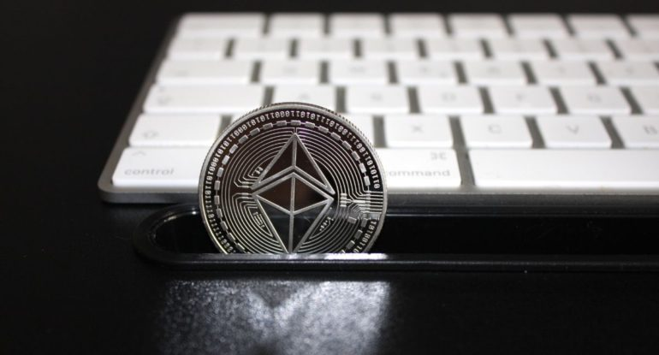

NFTs have been our entrée into Web3. But for the average person, the process of buying, storing, and protecting these NFTs is still pretty hard. Also, the wallet creation process, which must be done before any Web3 activity, whether it’s NFT or not, is a major barrier to mass adoption. So, ERC-4337 comes into play. This new [Ethereum upgrade](https://www.blockchainmagazine.net/ethereums-upgrade-will-reduce-energy-consumption-by-over-98/) could make blockchain technology easier for people who aren’t used to it to use. It could also offer benefits like recovering lost keys, not needing seed phrases, transactions that don’t use gas, and more.

Let’s talk about what ERC-4337 is, why it’s important, and what it might mean for the future of NFTs.

**Describe ERC-4337.**

[ERC-4337](https://eips.ethereum.org/EIPS/eip-4337), which stands for “Ethereum Request for Comment 4337,” is an upgrade to Ethereum that makes it possible to separate accounts. Account abstraction makes it possible for Ethereum wallets to act as smart contracts.

This means that each cryptocurrency wallet can have its own logic for authorising transactions that fits the needs of each user or application. Vitalik Buterin, one of the people who helped start Ethereum, and others came up with this upgrade idea in September 2021. It was announced at ETHDenver on March 1, 2023.

Up until now, making and using a wallet was hard, confusing, and scary for many people just starting out on Web3. New users have a hard time getting started with Bitcoin because it’s hard to get seed phrases, it’s scary to send your first transaction, and there aren’t many security features that are easy to use. ERC-4337 makes making and using wallets easier, making them more accessible.

This is a very important point for NFTs. NFTs have made getting into the space easier for regular people, old brands, and older intellectual properties. But if making a wallet stays hard to do, people will still be less likely to buy their first NFTs.

**What does ERC-4337 do?**

ERC-4337 fixes four major problems with the way wallets are built right now:

1. **Finds private keys that were lost**

One of the biggest risks and fears in the crypto space is that you will lose the private keys to your wallet. Only holding a valuable NFT that you lose is worse than buying one that goes to zero. It’s a scary fact of life in Web3. ERC-4337 makes it possible for a “social recovery system” to work, in which certain people can help you get back into your wallet if you lose your private keys.

1. **Wallets that are safe even without seed phrases**

ERC-4337 also lets users make secure wallets without seed phrases, which can be hard for some people to remember and keep safe.

Users can protect their wallets with 2FA (two-factor authentication) and biometrics with this update. This makes wallets much more secure and easy to use. But some people are in Web3 to protect themselves from the kind of institutional intrusion that security measures like biometrics represent. Also, seed phrases add an extra layer of security that some users might not want to give up.

Still, this feature can make setting up 2FA or biometric account access easier and more accessible for the many users who are interested in NFT and would be happy to do so.

ERC-4337 makes it easy to set recurring payments with spend limits. Hate it or love it, this will make subscriptions as common in web3 as they are in web2. [pic.twitter.com/hu3WacgcvE](https://t.co/hu3WacgcvE)

— 0xDesigner (@0xDesigner) [March 7, 2023](https://twitter.com/0xDesigner/status/1633122335866900480?ref_src=twsrc%5Etfw)

1. **Trading by computer**

When you collect and trade NFTs, you have to be very hands-on. This is one of the hardest parts. Keeping track of metrics, timing mints, and analysing floor prices all take a lot of work.

ERC-4337, on the other hand, allows automated trading, such as a limit on how much you can spend each month, AI trading, and changing the yield farming positions. These features can make trading NFTs much easier and more accessible for users of all skill levels.

1. **Gasless transactions**

Lastly, ERC-4337 lets transactions happen without using gas. With this feature, NFT collections and their DAOs can pay for users’ gas fees to make their transactions cheaper. In the same way, this feature lets you group transactions together, which makes them faster and more efficient.

This feature also lets an application’s tokens be used to pay transaction fees, which can also cut transaction costs by a lot. The main purpose of blockchains like Avalanche and its subnets is to make this possible.

Also, read – [Ethereum and NFTs: A Comprehensive Guide](https://www.blockchainmagazine.net/ethereum-and-nfts-a-comprehensive-guide/)

**What might change because of this?**

Overall, ERC-4337 has many of the same features as traditional banks, but you don’t have to trust a financial institution to use them. Because of this, ERC-4337 could make it much easier for people to use NFTs. This update could change the market by making it easier to buy, store, protect, and get back NFTs. But the features alone aren’t enough to get a lot of people to use them.

How we talk about ERC-4337 is the key to making the most of its potential. Even the term “account abstraction” and other technical terms won’t help people who aren’t already familiar with the space. In fact, we might need to get rid of the word “wallet” and use language that sounds more like web2: account creation, login, password recovery, etc.

No one outside of Web3 knows what those seven letters and numbers in ERC-4337 stand for. And they won’t have to if they can do everything else easily.

<https://blockchainmagazine.net/top-4-ways-the-latest-erc-4337-ethereum-upgrade-will-change-nft/>